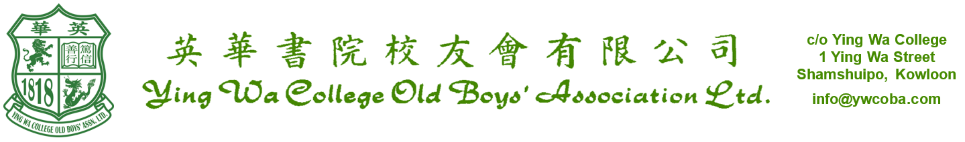
_______________________________________________________________

Minutes of the 2025 Annual General Meeting held at 7:30 p.m. on Friday,
21st November, 2025 at the Noble Hall, Ying Wa College,
1 Ying Wa Street, Shamshuipo, Kowloon, Hong Kong _____________________________________________________________________

Present : As per signatories in the attendance register

Chairman : Mr. LIU Lik Hang, Rex

1. The notice convening the meeting was taken as read.
2. The Chairman declared that the necessary quorum for convening the meeting was present.
3. Minutes of 2024 annual general meeting were approved unanimously.
Proposer : Mr. LAU Tin Shing Seconder : Mr. TANG Ping Kwong
4. The Chairman presented a report on the activities and affairs of the Association for the year 2024-2025.
It was resolved that the Chairman’s Report as presented and was hereby approved and adopted.
Proposer : Mr. TSANG Chiu Kwan Seconder : Mr. KWAN Kai Cheong
5. The audited financial statements for the year ended 30th June 2025 were laid before the meeting. It was resolved that the financial statements as presented and were hereby approved and adopted.
Proposer : Mr. LAM Hon Kit Seconder : Mr. TANG Ping Kwong
It was resolved that CCTH CPA Limited, certified public accountants, be appointed Honorary Auditors of the Association to hold office until the conclusion of the next Annual General Meeting.
A vote of thanks was extended to Mr. YIM Kai Pung.
Proposer : Mr. LAM Hon Kit Seconder : Mr. TANG Ping Kwong

6. The Trustees of the Ying Wa College Old Boys’ Association Charity Trust Fund presented the audited financial statements of the Charity Trust Fund for the year ended 30th June 2025 to members in accordance with Clause 17 of the Trust Deed. It was noted that Mr. MAK Siu Hong, Colus was re-appointed Honorary Auditor of the Charity Trust Fund.
A vote of thanks was extended to Mr. MAK Siu Hong, Colus.
Proposer : Mr. LAM Hon Kit Seconder : Mr. TANG Ping Kwong

7. The results of the election of President, Vice President and Executive Committee for the years 2025-2027.

President : Mr. Tsang Chiu Kwan
Vice President : Mr. Wong Man Kam, Patrick
Executive
Committee Members : Mr. KWAN Kai Cheong
Mr. LAU Tin Shing, Adi
Mr. SHUM Ping Sang, Edward
Mr. LO Kwing Yu
Mr. NG Chi Kwong, Gareth
Mr. FONG Pui Cheung
Mr. KO Chi Wan, Ivanhoe
Dr. LEE Wai Lun
Mr. MA Ka Man, Jason
Mr. LIU Lik Hang, Rex
Mr. WONG Tsz Wing
Mr. LU Pei Cheng, Carus
Mr. YEUNG Wai Yuen, Philip
Mr. LEE Tin Ho, Peter
Mr. CHIU Wai Lok, Sunny
Mr. POON Yiu Kei, Eric
Mr. LEE Chun Wai, Simon
Mr. LI Chun Wai, Edward
Mr. PUN Ching Yiu, Tony
Mr. CHIU Tsz Wang
Mr. LAM Hon Kit
There being no other business, the meeting was concluded at 8:00 p.m.
Confirmed this the day of November, 2026.

＿＿＿＿＿＿＿＿＿＿＿＿
Chairman

